Branch: MCA (Data Science) | Semester: 2
Student Name: Adarsh Mishra | UID: 25MCD10065
Subject Name: Technical Training - I Lab | Subject Code: 25CAP-652
Section/Group: 25MCD KAR-1 | Date of Performance: 03 Februrary,2026

EXPERIMENT – 04

Implementation of Iterative Control Structures using FOR, WHILE, and LOOP in PostgreSQL

Aim
To understand and implement iterative control structures in PostgreSQL conceptually, including FOR loops, WHILE loops, and basic LOOP constructs, for repeated execution of database logic.

Tools Used
- PostgreSQL

Objectives
- To understand why iteration is required in database programming
- To learn the purpose and behavior of FOR, WHILE, and LOOP constructs
- To understand how repeated data processing is handled in databases
- To relate loop concepts to real-world batch processing scenarios
- To strengthen conceptual knowledge of procedural SQL used in enterprise systems

Theory
In real-world database applications, tasks often need to be repeated multiple times. Examples include processing employee records, generating reports, validating data, applying salary increments, and running batch jobs. Standard SQL is declarative and works well for single operations, but repeated logic requires procedural control.
PostgreSQL provides PL/pgSQL, a procedural extension that supports iteration using loop structures. These loops allow SQL statements to execute repeatedly until a specific condition is met.
Iteration in PostgreSQL is commonly used inside:
- Stored procedures
- Functions
- Anonymous execution blocks
Large organizations such as Amazon, SAP, Oracle, and Rippling use loop-based logic for payroll processing, billing cycles, analytics, and automation workflows.

Types of Loops in PostgreSQL

FOR Loop (Range-Based)
  - Executes a fixed number of times
  - Useful when the number of iterations is known in advance
  - Commonly used for counters, testing, and batch execution

FOR Loop (Query-Based)
  - Iterates over rows returned by a query
  - Processes one row at a time
  - Frequently used for reporting, audits, and row-wise calculations

WHILE Loop
  - Executes repeatedly as long as a condition remains true
  - Suitable for condition-controlled execution
  - Often used in retry logic or threshold-based processing

LOOP with EXIT Condition
  - Executes indefinitely until explicitly stopped
  - Provides maximum control over execution flow

  - Used in complex workflows where exit conditions are custom-defined

Experiment Steps (Conceptual Explanation)

Example 1: FOR Loop – Simple Iteration
  - The loop runs a fixed number of times
  - Each iteration represents one execution cycle
  - Useful for understanding basic loop behavior
Application: Counters, repeated tasks, batch execution

Queries:
do $$ declare
i integer; begin
for i in 1..5 loop
raise notice 'iteration number: %', i; end loop;
end $$;

Output:
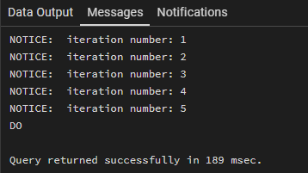

Example 2: FOR Loop with Query (Row-by-Row Processing)
  - The loop processes database records one at a time
  - Each iteration handles a single row

  - Simulates cursor-based processing
Application: Employee reports, audits, data verification

Queries:
create table employee ( emp_id serial primary key, emp_name varchar(50), salary numeric(10,2)
);
insert into employee (emp_name, salary) values ('arjun', 45000),
('meera', 72000),
('rohan', 88000),
('kavya', 60000),
('sameer', 95000);

do $$ declare
rec record; begin
for rec in
select emp_id, emp_name from employee order by emp_id loop
raise notice 'emp id: %, name: %', rec.emp_id, rec.emp_name; end loop;
end $$;

Output:
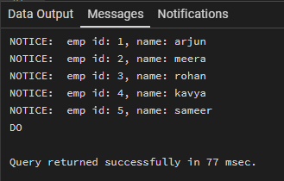

Example 3: WHILE Loop – Conditional Iteration
  - The loop runs until a condition becomes false
  - Execution depends entirely on the condition
  - The condition is checked before every iteration
Application: Retry mechanisms, validation loops

Queries:
do $$ declare
counter integer := 1; begin
while counter <= 5 loop
raise notice 'counter value: %', counter; counter := counter + 1;
end loop; end $$;

Output:
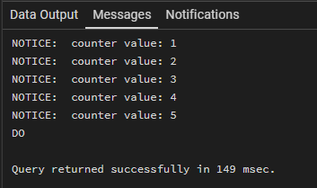

Example 4: LOOP with EXIT WHEN
  - The loop does not stop automatically

  - An explicit exit condition controls termination
  - Gives flexibility in complex logic
Application: Workflow engines, complex decision cycles

Queries:
do $$ declare
num integer := 1; begin
loop
raise notice 'number: %', num; num := num + 1;

exit when num > 5; end loop;
end $$;

Output:
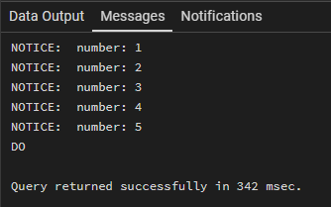

Example 5: Salary Increment Using FOR Loop
  - Employee records are processed one by one
  - Salary values are updated iteratively
  - Represents real-world payroll processing
Application: Payroll systems, bulk updates

Queries:
update employee set salary = case emp_name
when 'arjun' then 45000 when 'meera' then 72000 when 'rohan' then 88000 when 'kavya' then 60000 when 'sameer' then 95000
end;

do $$ declare
rec record; begin
for rec in
select emp_id from employee loop
update employee
set salary = salary + 5000 where emp_id = rec.emp_id;

raise notice 'salary incremented for emp id: %', rec.emp_id; end loop;
end $$;

Output:
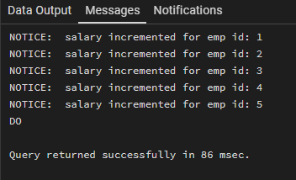

Example 6: Combining LOOP with IF Condition
  - Loop processes each record
  - Conditional logic classifies data during iteration
  - Demonstrates decision-making inside loops
Application: Employee grading, alerts, categorization logic

Queries:
do $$ declare
rec record; begin
for rec in
select emp_id, salary from employee loop
if rec.salary >= 80000 then
raise notice 'emp id % classified as high income', rec.emp_id; else
raise notice 'emp id % classified as regular income', rec.emp_id; end if;
end loop; end $$;

Output:
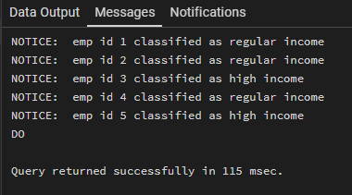

Learning outcomes (What I have learnt)
  - Understood the need for iteration in database programming
  - Learnt the working of FOR, WHILE, and LOOP constructs in PostgreSQL
  - Understood how repeated data processing is handled using PL/pgSQL
  - Learnt how loops are applied in real-world database scenarios
  - Gained foundational knowledge of procedural SQL used in enterprise systems

